Fox Valley Data Exchange
Data Structure and Framework Action and Advisory Team
Data Source Document
Contents
Data Source/Topic 1
Use Case 2
Input File Dimensions 2
Input Data File 2
Download Instructions 2
Discipline Actions_certified_Download File layout 2
File Lookups 3
School Address File 4
Stratifications File 4
Places File 5
Output Files for Metopio 5
Statewide Layer 7
Tri-County Layer 8
County Layer 8
Zip Code Layer 9
City or town Layer 10
Validation Method 10
Code to format the files 12
Authenticity 12
Comments 12

Data Source/Topic

Identifier | FVDEX-PP-9
Data Source Name | WISEdata
Data Source Link if any | WISEdash Public Portal - Department of Public Instruction  WISEdash Data Files by Topic | Wisconsin Department of Public Instruction  Download Type = ‘Discipline’  Input: the files that are named as discipline_actions_certified_2023-24.zip  including 2018 forward
Topic Name or other specifics within data source | Public School Disciplinary Action K-12
Vital Condition | Lifelong Learning
Requested by (name) | Sarahjean Schluechtermann
Update frequency | Yearly in September
Cost to obtain | free
Contact to obtain | none
Recorded by (Data Dingo conducting interview) | Susan Conzelman
Technical Solution | Shaaz Anaam

Use Case
This metric provides disciplinary actions taken for students enrolled in public schools in the Tri-County area. This helps identify which demographics are the recipients of disciplinary actions.

Input File Dimensions

Input Data File

Download Instructions
There is one file for each year which can be found in this link:
WISEdash Data Files by Topic | Wisconsin Department of Public Instruction
Filter Download Type dropdown to “Discipline”.
The files that begin with “discipline_actions_certified” followed by the school year range.zip are the ones to download. Click on the file name and open the file from your browser pop-up:
Copy the data file from the zip file folder:

Discipline Actions_certified_Download File layout
Columns used are in bold:
Field No | Field Name | Field Datatype | Length | Field Description
1 | SCHOOL_YEAR | Text | 7 | School year of enrollment
2 | AGENCY_TYPE | Text | 50 | School/district type
3 | CESA | Text | 10 | Cooperative Educational Service Agency
4 | COUNTY | Text | 50 | County of main district office
5 | DISTRICT_CODE | Text | 10 | District code - Unique 4 digit code assigned by DPI
6 | SCHOOL_CODE | Text | 10 | School code - 4 digit code unique within district and assigned by DPI
7 | GRADE_GROUP | Text | 50 | School grade group. Grade ranges of schools in the same GRADE_GROUP may vary. See also LOW_GRADE and HIGH_GRADE
8 | CHARTER_IND | Text | 4 | Whether school/district is a charter SCHOOL_NAME
9 | DISTRICT_NAME | Text | 100 | District name
10 | SCHOOL_NAME | Text | 100 | School name
11 | GROUP_BY | Text | 50 | Data group - student attribute name
12 | GROUP_BY_VALUE | Text | 200 | Data group - student attribute value
13 | REMOVAL_TYPE_DESCRIPTION | Text | 200 | Removal type description
14 | TFS_ENROLLMENT_COUNT | Text | 200 | Count of students enrolled on TFS in the data group
13 | REMOVAL_COUNT | Text | 20 | Count of student removals in the data group

File Lookups
In addition to the input file, we have other files that have further information needed to format the data for Metopio:

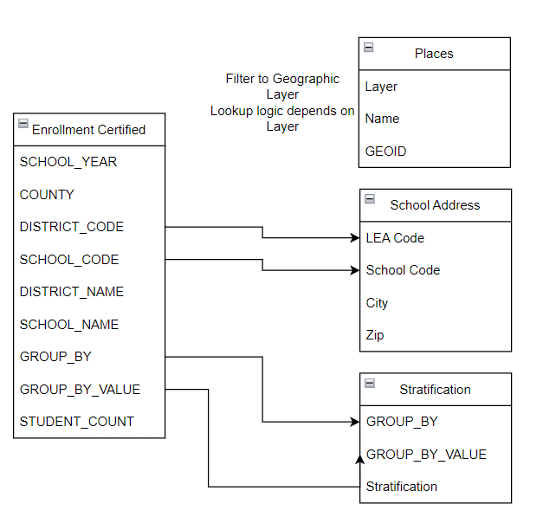

School Address File
WISEdash allows us to download the school directory file where we can get the zip code and city of the school to use for those aggregation layers. Do this lookup for every row in the Input File to add City and Zip.
Sd-export-public-schools-20241208.1059 (each year a new version needs to be downloaded)
If concatenating the two columns to make a key “string” to compare, be sure to remove leading zeroes from the fields being compared. Otherwise a match won’t be found.
Column | Column Heading | Comment
A | LEA Code | Join DISTRICT_CODE
C | School Code | Join SCHOOL_CODE
J | City | Set to “ERROR” if not found.
L | Zip | Set to “ERROR” if not found.

Stratifications File
Stratifications in Metopio each have a unique code. We need to translate the Group by fields and values into the ones we added there.
PP8 Stratifications.csv can be found in the FVDEX Teams Meeting Library. It may need to be updated if new values are found in new input files. PP8 and PP9 share the same stratifications.

Column | Column Heading | Comment
A | GROUP_BY | Join to GROUP_BY
B | GROUP_BY_VALUE | Join to GROUP_BY_VALUE
C | Stratification | Use this value in the output file

This file is manually created after adding the stratifications to the Metopio in the Administrator Site. Click on “Data” 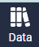 then “Stratifications” under “Topic Management”. Find the Metopio Stratification that will be used then click on its Name. Example:
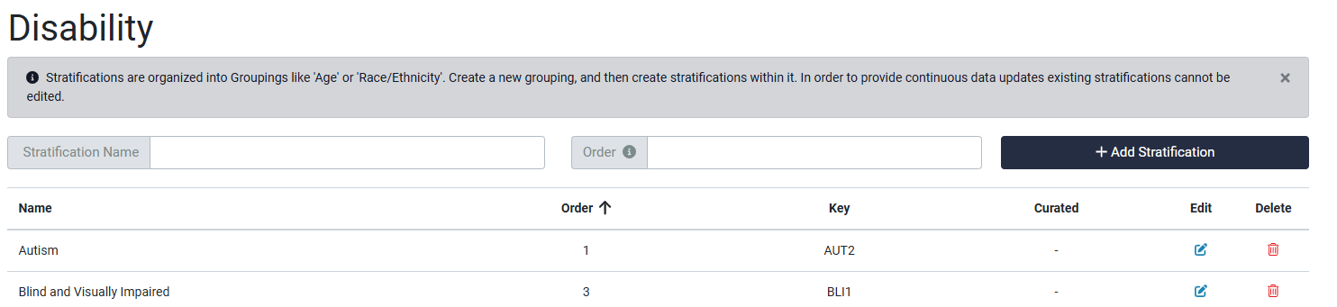
The “Key” is unique across all stratifications. This is what is needed in the Metopio upload file.

Places File
Fox Valley Data Exchange Places GEIODs.csv can be found in the FVDEX Teams Meeting Library. We use this file to obtain the GEOID used in Metopio for each place. This lookup is done differently for each aggregation layer below.
Column | Column Heading | Comment
A | Layer | Filter or join to the layer needed:  Region  County  Zip Code  City or town
B | Name | Join to this field using the input file
C | GEOID | Set to “ERROR” if not found.

This file was created manually by Metopio and sent to us. It can be recreated through the “Download” dropdown on the far left of the Atlas site, but this has to be done for each Geographic Layer and then combined. Since it doesn’t change, it is easier to simply use our saved file.

Output Files for Metopio

Format a .csv file with rows for each geographic layer. Steps:
1 – Read the above file and filter to these rows:

DISTRICT_NAME = [Statewide] or COUNTY = ‘Outagamie’, ‘Winnebago’, and ‘Calumet’
SCHOOL_NAME not=’Districtwide’
Group Value not = ‘[Data Suppressed]’
REMOVAL_COUNT not = ‘*’
REMOVAL_TYPE_DESCRIPTION = ‘Out of School Suspension’
2 – Do this to fill in redacted data totals so that every unique GROUP_BY value for each school is equal to the Total # of Students at the school
Why we are doing this: When data is redacted for a value in a GROUP_BY in order to preserve anonymity, other values may also be redacted. Example: 51.1% of the Gender are males. But when we remove Female and Non-binary, the result is 100%. We need to add a value of “Unknown” with the difference between the “All Students” total and the reported values for Gender.
Example 1 for a School:
GROUP_BY | GROUP_BY_VALUE | value
All Students | All Students | 15230
Gender | Female | *
Gender | Male | 7786
Gender | Non-binary | *

We change this to:
GROUP_BY | GROUP_BY_VALUE | value
All Students | All Students | 15230
Gender | Male | 7786
Gender | Unknown | 10644

Example 2 with more than one redaction:
GROUP_BY | GROUP_BY_VALUE | value
All Students | All Students | 15230
Disability | Autism | 393
Disability | Blind and Visually Impaired | 9
Disability | Deaf or Hard of Hearing | 30
Disability | Emotional Behavioral Disability | 245
Disability | Intellectual Disability | 100
Disability | Not IDEA Eligible or No Disability | 12694
Disability | Orthopedic Impairment | *
Disability | Other Health Impairment | 593
Disability | Significant Developmental Delay | 203
Disability | Specific Learning Disability | 488
Disability | Speech or Language Impairment | 466
Disability | Traumatic Brain Injury | *
Disability | Unknown | 1 we change to 9
We add 8 to “Unknown” since it already exists. We delete Orthopedic Impairment and Traumatic Brain Injury because they are redacted. These rows will not show up because of our earlier filter to remove them.

For DISTRICT_NAME = [Statewide] rows which has no redactions, loop through:
For each GROUP_BY
Total REMOVAL_COUNT including the preceding columns
If Total for each GROUP_BY < the Total for GROUP_BY = blank
Add a new row copying the GROUP_BY values with a REMOVAL_COUNT of the difference (GROUP_BY=blank total – the GROUP_BY) with GROUP_BY_VALUE = “Unknown”
Or you will add the difference to the “Unknown” row that already exists

For each DISTRICT_CODE, SCHOOL_CODE (not null)
For each GROUP_BY including the preceding columns
Total REMOVAL_COUNT
If Total for each GROUP_BY < the Total for GROUP_BY = blank
Add a new row copying the GROUP_BY values with a REMOVAL_COUNT of the difference (GROUP_BY=blank total – the GROUP_BY) with GROUP_BY_VALUE = “Unknown”
Or you will add the difference to the “Unknown” row that already exists

Finally after the above are done, look for any Group By categories that are missing for a School. Add the appropriate “Unknown” row for these with a value that matches the All Student total.

For each unique value of GROUP_BY in the PP8 Stratifications value (example: Disability)
For each SCHOOL_CODE that is not null
If there are no entries for that GROUP_BY and school_code
Add one by copying the “All Students” row for that school_code and changing “GROUP_BY” to the missing value and setting GROUP_BY_VALUE = “Unknown”

3 – Create the various place layers below, summing (value) by all the output columns and sorting by layer/geoid/stratification

Statewide Layer

Filter to:
DISTRICT_NAME = [Statewide]
Column Name | Comment (granularity/sample values/aggregation method for measures)
layer | ‘State’
geoid | ‘WI’
topic | ‘FVDEWVAR’
stratification | See above notes
period | SCHOOL YEAR, but insert ‘20’ on the second year’s range (after the hyphen). So 2023-24 becomes 2023-2024
value | REMOVAL_COUNT

Tri-County Layer

Filter to:
COUNTY = ‘Outagamie’, ‘Winnebago’, and ‘Calumet’

Column Name | Comment (granularity/sample values/aggregation method for measures)
layer | ‘Region’
geoid | ‘fox-valley’
topic | ‘FVDEWVAR’
stratification | See above notes
period | SCHOOL YEAR, but insert ‘20’ on the second year’s range. So 2023-24 becomes 2023-2024
value | REMOVAL_COUNT

County Layer

Filter to:
COUNTY = ‘Outagamie’, ‘Winnebago’, and ‘Calumet’

Column Name | Comment (granularity/sample values/aggregation method for measures)
layer | ‘County’
geoid | See notes above.  Filter Places source to Layer = ‘County’  Concatenate Input “COUNTY”, ‘ County, WI’ and match to Places.Name to get GEOID
topic | ‘FVDEWVAR’
stratification | See above notes
period | SCHOOL YEAR, but insert ‘20’ on the second year’s range. So 2023-24 becaomes 2023-2024
value | REMOVAL_COUNT

Zip Code Layer

Filter to:

COUNTY = ‘Outagamie’, ‘Winnebago’, and ‘Calumet’

Column Name | Comment (granularity/sample values/aggregation method for measures)
layer | ‘Zip Code’
geoid | Zip from School Address logic above
topic | ‘FVDEWVAR’
stratification | See above notes
period | SCHOOL YEAR, but insert ‘20’ on the second year’s range. So 2023-24 becaomes 2023-2024
value | REMOVAL_COUNT

City or town Layer

Filter to:

COUNTY = ‘Outagamie’, ‘Winnebago’, and ‘Calumet’

Column Name | Comment (granularity/sample values/aggregation method for measures)
layer | ‘City or town’
geoid | Filter the Place file to Layer = ‘City or town’.  Find the city for the school using the notes above to lookup School Address.  Concatenate to ‘, WI’  Match the concatenated SchoolAddress.City = Place.Name to get the GEOID  Set to “ERROR” if not found  3 towns are not included in the places file. Asked Metopio to add them.
topic | ‘FVDEWVAR’
stratification | See above notes
period | SCHOOL YEAR, but insert ‘20’ on the second year’s range. So 2023-24 becaomes 2023-2024
value | REMOVAL_COUNT

Validation Method
Step 1: For the most current year, manually mock up the expected Metopio load files using Excel pivot tables and vlookups to the lookup files.
Step 2: Compare the mock up to the output side by side with “true/false” comparisons on every column. “Pass” means that every cell matches.
Step 3: For additional years, we assume that the results will follow the norm, so we do not do mock-ups for those. Instead, we check for new stratifications and errors in the lookups.

Geo Layer | 2023 | 2022 | 2021 | 2020 | 2019 | 2018
State
Tri-County
County
Zip Code
City or Town

Step 4: Upload to Metopio to “unplublished” metric.
In the Administrator Tool, on the “Data” tab, under “Data Management”, click on “Upload Data”.
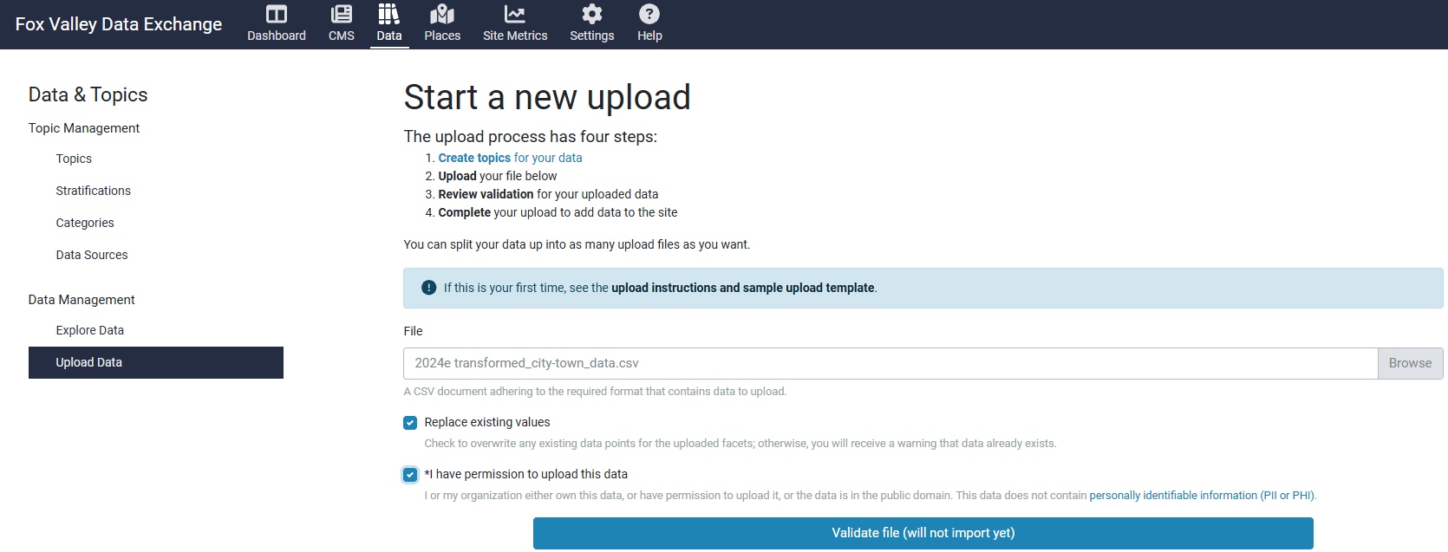
Click “Validate file (will not import yet)”
Scroll down on the list and click “Import Data” if there are no error messages:

Step 4: Spot Checks between Metopio and the source dashboard completed after loading the files.
If the Topic is not visible in the Atlas yet, we spot check from the Administrator tool. Click “Data” tab. Click “Explore Data” under “Data Management” (or Explore Data from the Topics entry). Spot check some of the values in the listed data.
Geo Layer | 2023 | 2022 | 2021 | 2020 | 2019 | 2018
State
Tri-County
County
Zip Code
City or Town

Step 5: March 2025 data load signed off by the FVDEX Executive Director on _______________________.
Step 6: Make data visible to public. In Administrator site, click “Data” tab and “Topics” under “Topic Management”. Edit and turn on Public View.
Step 7: Spot Check Metopio Dashboard to WISEDash. Check the map, chart, etc for new data added.
Step 8: Have requester review the topic
Step 9: Communicate the new topic to the Action Committee.

Code to format the files
This link has the Python code developed to format the Metopio upload files. Start with the “Readme” file.
https://github.com/shaazanaam/__wes_dataProcessor__.git

Authenticity

An "out-of-school suspension" (also known as "suspension") is a removal from school grounds imposed by the school administration for noncompliance with school district policies or rules; for threatening to destroy school property; or for endangering the property, health, or safety of those at school.
WISEdata is a multi-vendor, open data collection system that allows school districts, charter schools, and private schools participating in a parental Choice program to submit data to the Department of Public Instruction (DPI) from the student information system (SIS) vendor of their choice.

Comments

Hi Sarah Jean,

I’m working on loading the Disciplinary Action metric now. Unfortunately, this topic has three demographic layers and Metopio can only handle two. So we have some choices to make:

Proposed Name: # of Students Expelled or Suspended in

Here is a statewide example for gender:
Strat | Sub-Strat | Removal Type | Total Enrolled | Total Disciplined
Gender | Female | Expulsion with Services Offered | 398216 | 182
Gender | Female | Expulsion without Services Offered | 398216 | 127
Gender | Female | Out of School Suspension | 398216 | 28073
Gender | Male | Out of School Suspension | 424235 | 53976
Gender | Male | Expulsion without Services Offered | 424235 | 183
Gender | Male | Expulsion with Services Offered | 424235 | 288
Gender | Non-binary | Expulsion with Services Offered | 353 | 1
Gender | Non-binary | Out of School Suspension | 353 | 29
Gender | Unknown | Out of School Suspension | 0 | 14

Here are our options:
1 – Add the three removal types to one total by demographic group. Pro: see all demographics easily who were disciplined. Con: Don’t know detail disciplines, but people could go to WISEdash for more details if needed. This is the option I prefer, but will is it enough?

Public School K-12 Expelled or Suspended

Strat | Sub-Strat | Total Enrolled | Total Disciplined
Gender | Female | 398216 | 28382
Gender | Male | 424235 | 54447
Gender | Non-binary | 353 | 30
Gender | Unknown | 0 | 14

2 – Add each removal type as a separate topic by demographic group in addition to the total suggested above. Pro: see all demographics easily who were disciplined. Con: The individual removal types can’t be viewed together.

Public School K-12 Expelled or Suspended
Public School K-12 Expelled with Svc Offer
Public School K-12 Expelled without Svc Offer
Public School K-12 Out of School Suspension

3 – Combine the current Strat and Sub-Strat values into one that sits under the removal type:

Removal Type
Strat + Sub-Strat

Would look like this in stratifications:

